SIMATS ENGINEERING
CO5-ASSESSMENT TOOL 3

COURSE NAME: DIGITAL CIRCUITS COURSE CODE: ECA02

COURSE OUTCOME COVERED
CO:5 Analyze the operation and characteristics of NMOS and PMOS transistors, CMOS inverters, and MOS device parameters used in digital circuit design (BTL 3 & 4)

Assessment Tool number : AT3
Assessment Tool Weightage : 40%
Assessment Tool Name : HDL Code Error Debugging
Duration of this assessment : 90 Minutes
Marks : 20
Type of Assessment conduction : Inside Class

Description:

- Each student will be assigned one HDL Code Error Debugging problem 20 marks inside class. Analyze and debug one faulty analog circuit.
- Simulate the corrected circuit using VIVADO and verify results.
- Document the debugging process, observations, and conclusions.
- Upload VIVADO files, simulation results, and report to GitHub.
- Evaluation is based on fault identification, debugging approach, simulation accuracy, documentation, and GitHub submission.

Item | Student Entry
1. Given Code | module down_counter(  input clk,  output reg [2:0] Q);  always @(negedge clk)  begin  Q <= Q + 1;  end  endmodule
2. Expected code output | 7 → 6 → 5 → 4 → 3 → 2 → 1 → 0 → 7 → ...
3. Observed Fault / Symptom | 0 → 1 → 2 → 3 → 4 → 5 → 6 → 7 → ...
6. Error Identified | Q <= Q + 1;
7. Correction Made | Q <= Q - 1;
8. Corrected HDL code | module down_counter(  input clk,  output reg [2:0] Q  );  always @(negedge clk)  begin  Q <= Q - 1;  end  endmodule
9. Verification / Simulation Output | 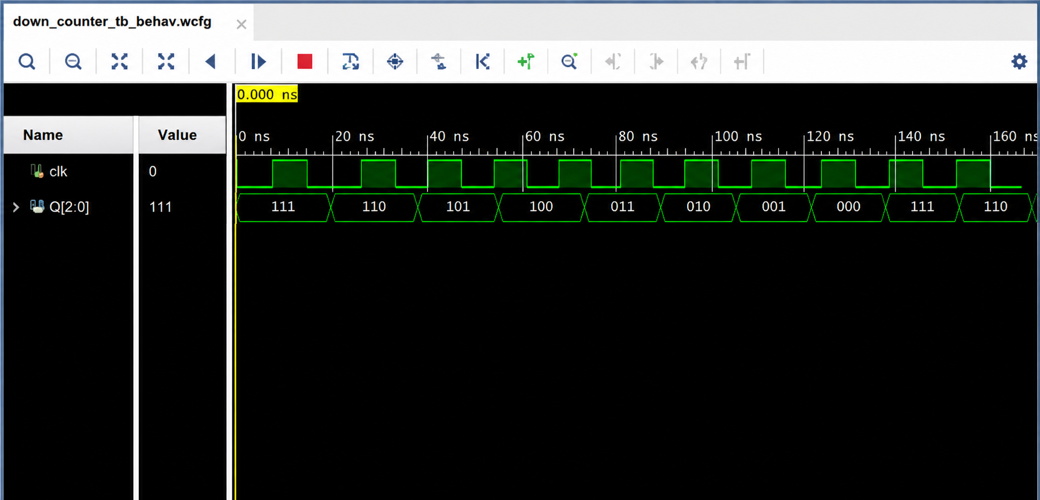
10. Final Result & Technical Justification | The logical error was successfully identified and corrected. The original code performed up-counting because it used Q + 1. After replacing it with Q - 1, the circuit performs the required 3-bit down-counting operation on every negative edge of the clock.

